### [VISVESVARAYA TECHNOLOGICAL UNIVERSITY](http://www.vtu.ac.in/)

“Jnana Sangama”, Belagavi – 590018



A Project Report ON

#### NIYUKTHI APPOINTMENT SCHEDULING APPLICATION USING ROBOTIC PROCESS AUTOMATION

BY

#### SHAMEEL AHMED 4MT17CS094

**SURAKSHA RANI 4MT17CS110**

**SUSHMITHA SHETTY 4MT17CS111**

**VARSHINI RAO I K 4MT17CS119**

**Project Guide Shivaprasad T K, Assistant Professor**

**Department of CS & Engg MITE, Moodabidri**



**DEPARTMENT OF COMPUTER SCIENCE & ENGINEERING**

(Accredited by NBA)

### MANGALORE INSTITUTE OF TECHNOLOGY & ENGINEERING

(An ISO 9001:2015 Certified Institution)

#### BADAGA MIJAR, MOODABIDRI DK DIST-574225

**MANGALORE INSTITUTE OF TECHNOLOGY & ENGINEERING**

(An ISO 9001:2015 Certified Institution)

#### BADAGA MIJAR, MOODABIDRI, DK DIST – 574225



**DEPARTMENT OF COMPUTER SCIENCE & ENGINEERING**

CERTIFICATE

|  |  |  |
| --- | --- | --- |
| This is to certify | that the project work | entitled **NIYUKTHI APPOINTMENT** |
| **SCHEDULING** | **APPLICATION** | **USING ROBOTIC PROCESS** |
| **AUTOMATION** | is a bonafide work | carried out by **SHAMEEL AHMED** |

#### (4MT17CS094), SURAKSHA RANI (4MT17CS110), SUSHMITHA SHETTY

**(4MT17CS111), VARSHINI RAO I K (4MT17CS119)** in partial fulfillment for the award of degree of **Bachelor of Engineering in Computer Science & Engineering of the Visvesvaraya Technological University, Belagavi during the year 2020 – 2021**. It is certified that all corrections and suggestions indicated for Internal Assessment have been incorporated in the report deposited in the departmental library. The project has been approved as it satisfies the academic requirements in respect of project work prescribed for the Bachelor of Engineering degree.

|  |  |  |
| --- | --- | --- |
| **………………………..** | **…………………………..** | **…………………………….** |
| **Shivaprasad T K** | **Dr. Venkatramana Bhat P** | **Dr. G. L. Easwara Prasad** |
| **Assistant Professor**  **External Viva** | **Head of the Department** | **Principal** |
| **Name of the Examiners** |  | **Signature with Date** |
| **1)** |  |  |
| **2)** |  |  |

## ABSTRACT

An RPA tool could be implemented to turn an employee-driven process into a service station that patients or customers can use on their own. Robotic Process Automation (RPA) emerges as software- based solution to automate rules-based business processes that involve routine tasks, structured data and deterministic outcomes. Usually after booking the appointment patient has to wait for longer duration in hospital for consultation. To overcome this problem, we have proposed a project which is a website that aims to provide information about the patient. This reduces mundane or repeated task of hospital employee, which makes hospital management to store and maintain data easily using Robotics Process Automation. The objective of the Appointment System is to manage the details of Patient, Doctor and Appointment. The project is built from both the end the patient and the administrator. RPA software can then automate the responses to the patient’s input, which would load their information in Desktop application. Initially website takes data from patient which will be stored in database for each patient and generates QR Code. This can be used for later purpose when patient enter hospital, device detects patient identification. A service terminal is set up in the hospital to allow patients to Check-in and Check-out. RPA software will calculate the service time based on the input and reschedule the appointment if needed.

The satisfaction and the successful completion of this project would be incomplete without the mention of the people who made it possible, whose constant guidance encouragement crowned our efforts with success.

This project is made under the guidance of **Mr. Shivaprasad T K**, **Designation**, in the Department of Computer Science and Engineering. We would like to express my sincere gratitude to our guide for all the helping hand and guidance in this project.

We would like to thank our project coordinator **Mr. Shivaprasad T K, Sr. Assistant Professor** in the Department of Computer Science and Engineering, for his cordial support, valuable information and guidance, which helped us in completing this project through the various stages.

We would like to express appreciation to **Dr. Venkatramana Bhat P.,** Professor and Head, Department of Computer Science and Engineering, for his support and guidance.

We would like to thank our Principal **Dr. G.L. Easwara Prasad**, for encouraging us and giving us an opportunity to accomplish the project.

We also thank our management who helped us directly or indirectly in the completion of this project. Our special thanks to faculty members and others for their constant help and support.

Above all, we extend our sincere gratitude to our parents and friends for their constant encouragement with moral support.

##### SHAMEEL AHMED (4MT17CS094) SURAKSHA RANI (4MT17CS110) SUSHMITHA SHETTY (4MT17CS111) VARSHINI RAO I K (4MT17CS119)

|  |  |  |
| --- | --- | --- |
|  | **Contents** | **Page No** |
| **ABSTRACT** |  | i |
| **ACKNOWLEDGEMENT** | | ii |
| **TABLE OF CONTENTS** | | iii |
| **LIST OF TABLES** | | iv |
| **LIST OF FIGURES** | | v |
| **LIST OF SYMBOLS, ABBREVATIONS** | | vi |
| **Chapter no** | **TITLE** |  |
| **1** | **INTRODUCTION** |  |
| 1.1 | Introduction | 1 |
| 1.2 | Problem Statement | 1 |
| 1.3 | Objectives (Purpose of the project) | 1 |
| 1.4 | Scope of the project | 1 |
| 1.6 | Organization of the report | 2 |
| **2** | **LITERATURE SURVEY** | 3 |
| 2.1 | Existing System | 3 |
| 2.2 | Limitations of existing systems | 4 |
| 2.3 | Proposed System | 4 |
| **3** | **SYSTEM REQUIREMENTS SPECIFICATION** | 5 |
| 3.1 | Overall description | 5 |
|  | 3.1.1 Product Perspective | 6 |
|  | 3.1.2 Product Functions | 6 |
|  | 3.1.3 Assumptions and Dependencies | 6 |
| 3.2 | Specific Requirements | 6 |
|  | 3.2.1 Hardware Requirements | 6 |
|  | 3.2.2 Software Requirements | 6 |
|  | 3.2.3 Functional Requirements | 9 |
|  | 3.2.4 Non-functional Requirements | 9 |
| **4** | **GANTT CHART** | 11 |

|  |  |  |  |
| --- | --- | --- | --- |
| **5** | | **SYSTEM DESIGN** |  |
| 5.1 | | Architectural Diagram | 13 |
| 5.2 | | Class Diagram | 14 |
| 5.3 | | Use Case Diagram and Description | 15 |
| 5.4 | | Sequence Diagram | 16 |
| 5.5 | | Activity Diagram | 17 |
| 5.6 | | Data flow Diagram | 19 |
| **6** | | **IMPLEMENTATION** |  |
| 6.1 | | Module implementation | 20 |
|  | | 6.1.1 Module 1 | 20 |
|  | | 6.1.2 Module 2 | 20 |
| **7** |  | **TESTING**  Test Levels   * + 1. Unit Testing     2. Integration Testing     3. System Testing     4. Acceptance Testing Test cases   **RESULTS AND SNAPSHOTS CONCLUSION AND FUTURE WORK**  Conclusion Future Work |  |
|  | 7.1 | 21 |
|  |  | 21 |
|  |  | 21 |
|  |  | 22 |
|  |  | 22 |
|  | 7.2 | 22 |
| **8** |  | 24 |
| **9** |  |  |
|  | 9.1 | 32 |
|  | 9.2 | 33 |
|  |  | 34 |
| **REFERENCES** | | |  |

**LIST OF TABLES**

**Tables Page No.**

##### Table 4.1: Gantt chart of planning and scheduling of project 11

##### Table 7.2: Test cases for project 23

LIST OF FIGURES

TITLE PAGE NO.

Figure 8.1: Sign up page 24

Figure 8.2: Login in page 24

Figure 8.3: Patient Details 25

Figure 8.4: Availability page 25

Figure 8.5: Add Doctor page 26

Figure 8.6: Register page 26

Figure 8.7: Login page 26

Figure 8.8: QR Code 27

Figure 8.9: Home page 27

Figure 8.10: About Us page 28

Figure 8.11: Make Appointment and Cancel Appointment page 28

Figure 8.12: Department page 29

Figure 8.13: Doctors Available page 29

Figure 8.14: Booking Appointment page 30

Figure 8.15: Appointment cancelled SMS 30

Figure 8.16: My Appointment page 31

Figure 8.17: Reset Password page 31

**Chapter – 1 INTRODUCTION**

**INTRODUCTION**

In this chapter, we are going to give the introduction about the Niyukthi – Appointment Scheduling Application using RPA.

* 1. **Introduction**

The term “Appointment” refers to the period of time allocated in the schedule to a particular patient’s visit. “Service time” refer to the amount of time the physician actually spends with the patient which may be shorter or longer than the appointment duration. Online appointment scheduling software provides customers with portal to book an appointment online and enables the receptionist to track and manage those appointments. The software enables receptionist to add appointments, add availability, view calendar, and view appointments scheduled. Additional features include cancellation, rescheduling and notify patients about their appointment. Have a scheduler that can be viewed, managed and edited by receptionist or multi-user.

#### Problem Statement

Outpatients use waiting time and data protection by the cyberattack as the decisive factor in choosing service provider. The project aims to understand patients’ needs and the availability of doctors to book the appointment and manage it. RPA is used to automate the Check In/Out process and to reschedule the appointment.

#### Objectives

The main objective of the Appointment System is to manage the details of Patient, Doctor and Appointment. The project is built from both the end the patient and the administrator. The purpose of the project is to build an application to reduce the manual work of the receptionist. It tracks all the details about the Patient and Doctor. RPA software can then automate the responses to the patient’s input, which would load their information into a triage system and allow the front desk employees to review each patient’s information. A self setup terminal is set up in the hospital to allow patients to Check-in and Check-out. RPA software will calculate the service time based on the input and reschedule the appointment if needed.

#### Scope

Using RPA, healthcare can automate the Check-in process for patients by using service terminals integrated into the facility’s database. Dashboard will take simple data receiving and entry tasks that it could repeat over and over for each patient.

#### Organization of the Report

**Chapter 1** starts by introducing the topic, which gives an insight and in-depth analysis of the project work, which was closely followed by the problem statement which tells about the problems faced by women, followed by the objectives of the topic, which gave rise to the significance of the topic, followed by the scope and crowned by the organization of the project.

**Chapter 2** deals with the literature review, Existing system, Limitations of existing system and proposed system.

**Chapter 3** focuses on System requirements specification, Overall description, Specific requirements like hardware and software requirements, functional and non-functional requirements.

**Chapter 4** has Gantt chart which gives overall schedules of project.

**Chapter 5** which has Architectural diagram, Class diagram, Use case diagram, Sequence diagram, Dataflow diagram.

**Chapter 6** focuses on the implementation part.

**Chapter 7** consists of results and snapshots of overall project.

**Chapter 8** is the conclusion part followed by future work.

**Chapter 9** enumerates references.

# Chapter – 2 LITERATURE SURVEY

### LITERATURE SURVEY

A literature survey or a literature review in a project report is that section which shows the various analysis and research made in the field of our interest and the results already published, taking into account the various parameters and the extent of the project.

#### Existing system

##### Fatma Poni Mardiah, Mursyid Hasan Basri

* + “The Analysis of Appointment System to Reduce Outpatient Waiting Time at Indonesia’s Public Hospital”.
  + Outpatient services have become an important component of health care.
  + Long waiting times for treatment in the outpatient department followed by short consultations has long been a complaint. Nowadays, customers use waiting time as a decisive factor in choosing a service provider.
  + Therefore, idle time of both parties must be considered in designing an appointment system although these two objectives are contradicted to each other.
  + This research aims to provide a study of the major causes of patients’ length of time for medical treatment in a outpatient clinic at one of Indonesian public hospital and also provide recommendation on the best strategy to improve the appointment system so that can maximize the effectiveness and efficiency of resource and capacity.
  + The technique used was Queuing Model for Specialist Outpatient Clinic.

##### Wenjun Cao et.al

* + “A web-based appointment system to reduce waiting for outpatients: A retrospective study”.
  + Long waiting times for registration to see a doctor is problematic in China, especially in tertiary hospitals. To address this issue, a web-based appointment system was developed for the Xijing hospital.
  + The aim of this study was to investigate the efficacy of the web-based appointment system in the registration service for outpatients.
  + Data from the web-based appointment system in Xijing hospital from January to December 2010 were collected using a stratified random sampling method, from which participants were randomly selected for a telephone interview asking for detailed information on using the system. Patients who registered through registration windows were randomly selected as a comparison group, and completed a questionnaire on-site.
  + Compared to the usual queuing method, the web-based appointment system could significantly increase patient's satisfaction with registration and reduce total waiting time effectively. However, further improvements are needed for broad use of the system.

#### Limitations of existing systems

* + 1. Long waiting times for treatment in the outpatient department followed by short consultations has long been a complaint.
    2. Lack of security to patient data and inconsistency is data.
    3. The receptionist has to manually manage the basic details of the patient and rescheduling and cancellation of appointment.

#### Proposed System

* A user-friendly website with a clear user interface and easy to use buttons. Patient access a website and makes an appointment, then go to the hospital, wait in a line for a number of hours, just to make an appointment with the doctor for the next week or next month. And through this, patients can also involve in the health decisions that they have to make. They can make an appointment to another doctor other than theirs, by nothing more than a click.
* The patient also wishes to be seen either immediately or within minutes of their arrival (whether they scheduled an appointment or not). The time that the patient waits from the scheduled start time of their appointment to the time that they actually receive service is called direct waiting time. The patients using this method waste much unnecessary waiting time standing in line at the registration window to ensure a successful registration with a certain physician. Using our system this can be reduced.
* In online appointment scheduling system patients are given an appointment time. At the designated appointment time, patients arrive at the hospital and get the Consultation done to that allotted time. These patients need not queue at the registration window. In this way both direct and indirect waiting time can be minimized and hospital’s valuable resources can be utilized efficiently.

# Chapter – 3

**SYSTEM REQUIREMENT SPECIFICATION**

### SYSTEM REQUIREMENT SPECIFICATION

A software requirements specification (SRS) is a description of a software system to be developed. The software requirements specification lays out functional and non-functional requirements, and it may include a set of use cases that describe user interactions that the software must provide. Use cases are also known as functional requirements. In addition to use cases the SRS also contains non-functional requirements. Non-functional requirements are requirements which impose constraints on the design or implementation. For the hardware requirements the SRS specifies the logical characteristics of each interface between the software product and the hardware components. It specifies the hardware requirements like memory restrictions, cache size, the processor, RAM size etc. those are required for the software to run. Software requirements specification is a rigorous assessment of requirements before the more specific system design stages, and its goal is to reduce later redesign.

#### Overall Description

The SRS is a document, which describes completely the external behavior of the software. This section of the SRS describes the general factors that affect the product and its requirements. The system will be explained in its context to show how the system interacts with other systems and introduce the basic functionalities of it.

#### Product Perspective

* + - * General users use this application for getting information about availability of doctors in the hospital and book the appointment.
      * Patients can cancel the appointment.
      * Notifying the patient about rescheduling appointment.

#### Product Function

Our proposed project is a website which aims to provide information about the patient, which reduces mundane or repeated task of hospital employee, which makes hospital management to store and maintain data easily. Initially website takes data from patient which will be stored in database for each patient and generates QR Code.

#### Assumptions and Dependencies

##### Assumptions

* + - * Helps to track Patient Flow based on arrival, visit and departure time.

##### Dependencies

* + - * Dependent on QR Code based Check-in and Check-out.
      * Dependent on Cancel the appointment.
      * Check Doctors availability for patient’s appointment.
      * Active internet connection.

#### Specific Requirements

This section includes the detailed description about the hardware requirements, software requirements, functional requirements and non-functional requirements.

#### Hardware Requirements

Hardware requirements refer to the physical parts of a computer and related devices. Internal hardware devices include motherboards, hard drives and RAM External hardware devices include monitors, keyboards, mice, printers, and scanner.

* + - * Processor: Minimum 1 GHz.
      * Hard Drive: Minimum 32 GB.
      * Memory (RAM): Minimum 4 GB and Above.
      * Android phone with minimum of 2GB RAM and storage space of 50MB.

#### Software Requirements

Software requirement is a field within Software Engineering that deals with establishing the Deeds of stakeholders that are to be solved by the software. The software requirements of our project given below:

* + - * HTML
      * CSS
      * JavaScript
      * Django
      * Tkinter
      * Firebase
      * UiPath Studio
      * UiPath Robot
      * UiPath Orchestrator

##### HTML5

HTML which stands for Hyper Text Mark-up Language, is the predominant mark-up language for web pages. It provides a means to create structured documents by denoting structural semantics for text such as headings, paragraphs, lists etc., as well as for links, quotes, and other items. It allows images and objects to be embedded and can be used to create interactive forms. It is written in the form of HTML elements consisting of "tags" surrounded by angle brackets within the web page content. It can include or can load scripts in languages such as JavaScript which affect the behavior of HTML processors like Web browsers and Cascading Style Sheets (CSS) to define the appearance and layout of text and other material. The W3C, maintainer of both HTML and CSS standards, encourages the use of CSS over explicit presentational mark-up.

##### CSS3

CSS3 is the latest evolution of the Cascading Style Sheets language and aims at extending CSS2.1It is used with HTML to create content structure, with CSS3 being used to format structured content. It is used with HTML to create content structure, with CSS3 being used to format structured content. It is responsible for font properties, colors, text alignments, graphics, background images, tables and other components. This tool provides extra capabilities such as absolute, fixed and relative positioning of various elements. To help build highly interactive online pages, CSS3 is strongly recommended due to its importance in providing greater options in the design process.

##### JavaScript

JavaScript is a dynamic computer programming language. It is lightweight and most commonly used as a part of web pages, whose implementations allow client-side script to interact with the user and make dynamic pages. It is an interpreted programming language with object-oriented capabilities. JavaScript is a programming language used primarily by Web browsers to create a dynamic and interactive experience for the user. Most of the functions and applications that make the Internet indispensable to modern life are coded in some form of JavaScript. JavaScript is most commonly used as a client-side scripting language. This means that JavaScript code is written into an HTML page.

##### Django

Django is a high-level Python web framework that enables rapid development of secure and maintainable websites. Built by experienced developers, Django takes care of much of the hassle of web development, so you can focus on writing your app without needing to reinvent the wheel.

##### Tkinter

Python offers multiple options for developing GUI (Graphical User Interface). Out of all the GUI methods, tkinter is the most commonly used method. It is a standard Python interface to the Tk GUI toolkit shipped with Python. Python with tkinter is the fastest and easiest way to create the GUI applications. Creating a GUI using tkinter is an easy task.

##### Firebase

[Firebase,](https://firebasetutorials.com/what-is-firebase/) Backend-as-a-Service (BaaS), is a platform by Google that provides functionalities and helps with the backend development of your Android, iOS, or web and even some products that support Unity3D too.

Top functionalities are:

* + [Firebase Database](https://firebasetutorials.com/firebase-database/): used to store user’s data like chat messages, users details and other metadata
  + [Firebase Cloud Storage](https://firebasetutorials.com/use-firebase-storage/): used to store user-generated content like the profile picture, multimedia messages, etc.
  + [Firebase Cloud Messaging](https://firebasetutorials.com/grow/cloud-messaging/): used to send notification.
  + [Firebase Remote Config](https://firebasetutorials.com/firebase-remote-config-force-update/): used to perform A/B testing on the go.

##### UiPath Studio

UiPath Studio is advanced automation software that gives everyone, from business users to advanced RPA developers, the right automation canvas to build great software robots—and organizations the right governance tools to manage them all. Design automations fast with an easy drag-and-drop editor. Simply record your workflows; skip the error-prone manual programming. Grab pre-built automation activities from UiPath Marketplace to help you build automations faster and easier. Support every department and workflow with collaboration tools and easy third-party component integration. Use shareable and reusable components to make you more collaborative—and productive.

##### UiPath Robot

UiPath Robot is the execution host that runs processes built in UiPath Studio. In Orchestrator, a robot entity represents an image of UiPath Robot and controls its capabilities. The Robot documentation guide in the UiPath suite can be found here. In this guide, the focus is on robot entities as found in Orchestrator and the capabilities they provide for UiPath Robot based on their types. For

this guide's purpose, we assume that a machine represents a physical or virtual machine on which UiPath Robot is installed. In Orchestrator, there are two machine entities that work as API key generators, which authorize the connection between UiPath Robot and Orchestrator.

##### UiPath Orchestrator

UiPath Orchestrator is a web application that enables you to orchestrate your UiPath Robots in executing repetitive business processes. Orchestrator lets you manage the creation, monitoring, and deployment of resources in your environment. It acts as an integration point with third-party solutions and applications. Its power comes from its capability of managing your entire Robot fleet.

#### Functional Requirements

Functional requirements describe the system function in detail, its input and output Functional requirements may explicitly state what the system should do These requirements depend on the type of software being developed the expected users of the software. It gives the overall details of how the proposed system works.

* + - * Operating system Windows 7 or above.
      * Chrome v8.
      * Android v7 or above.
      * Hard Drive: Minimum 32 GB.
      * Active internet connection.

#### Non-Functional Requirements

Non-functional requirements are the requirements which are not directly concerned with the specific function delivered by the system. They specify the criteria that can be used to judge the operation of a system rather than specific behavior. They may relate to Emergent system properties such as reliability, response time and store occupancy, non functional requirements anise through the user needs, because of budget constraints, organizational policies and the need for interoperability with other software.

* + - * Reliability: The reliability of the work depends on the constraints mentioned above.
      * Robustness: Based on the specified work the system works with high robustness.
      * Maintainability Requirements: The maintenance of software is the only requirement.
      * Availability: Availability Requirement is any requirement that is not a functional, data or process requirement concerned with defining the periods when the solution can be used.
      * Security: The security property requirements specify the properties that software must exhibit. The software must remain resilient in the face of attacks. The behaviour of the software must be correct and predictable.

# Chapter – 4 GANTT CHART

## GANTT CHART

A Gantt chart is a type of bar chart, developed by Henry Gantt that illustrates a project schedule. Gantt charts illustrate the start and finish of the terminal elements and summary elements of the project. Terminal elements and summary elements comprise the work breakdown structure of the project.

The following is the Gantt chart of the project “NIYUKTHI APPOINTMENT SCHEDULING APPLICATION USING RPA”

##### Table 4.1: Gantt chart of planning and scheduling of project

|  |  |  |  |  |
| --- | --- | --- | --- | --- |
| **Number** | **Task** | **Start** | **End** | **Duration(days)** |
| 1 | Synopsis | 5-Nov-2020 | 11-Nov-2020 | 7 |
| 2 | Presentation on idea | 19-Dec-2020 | 19-Dec-2020 | 1 |
| 3 | Software Requirement  Specification | 1-Jan-2020 | 12-Jan-2021 | 12 |
| 4 | System Design | 13-Jan-2021 | 23-Jan-2021 | 10 |
| 5 | Implementation | 1-Mar-2021 | 28-May-2021 | 89 |
| 6 | Presentation on work  progress | 4-Jun-2021 | 20-Jun-2021 | 16 |
| 7 | Testing | 21-Jun-2021 | 25-Jun-2021 | 5 |
| 8 | Result and Report | 26-Jun-2021 | 5-Jul-2021 | 10 |

|  |  |  |  |  |  |  |  |  |  |
| --- | --- | --- | --- | --- | --- | --- | --- | --- | --- |
| ACTIVITY/ MONTH | NOV | DEC | JAN | FEB | MAR | APR | MAY | JUN | JUL |
| SYNOPSIS |  |  |  |  |  |  |  |  |  |
| PRESENTATION ON IDEA |  |  |  |  |  |  |  |  |  |
| SOFTWARE REQUIREMENT  SPECIFICATION |  |  |  |  |  |  |  |  |  |
| SYSTEM DESIGN |  |  |  |  |  |  |  |  |  |
| IMPLEMENTATION |  |  |  |  |  |  |  |  |  |
| PRESENTATION ON PROGRESS |  |  |  |  |  |  |  |  |  |
| TESTING |  |  |  |  |  |  |  |  |  |
| REPORT |  |  |  |  |  |  |  |  |  |

**Chapter – 5 SYSTEM DESIGN**

* 1. **Architectural Design**

**SYSTEM DESIGN**

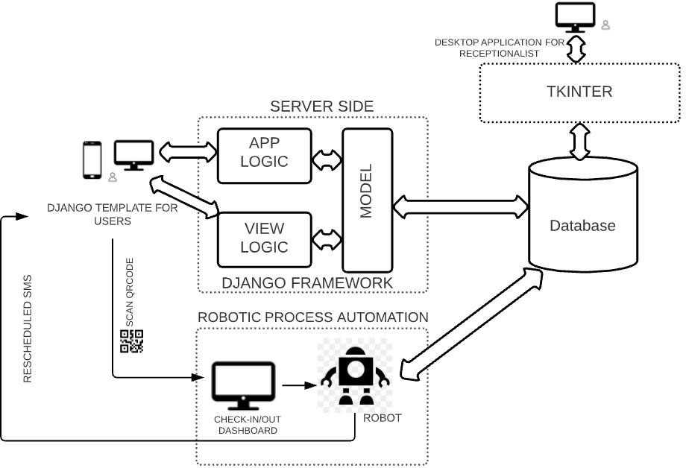

* 1. **Class Diagram**

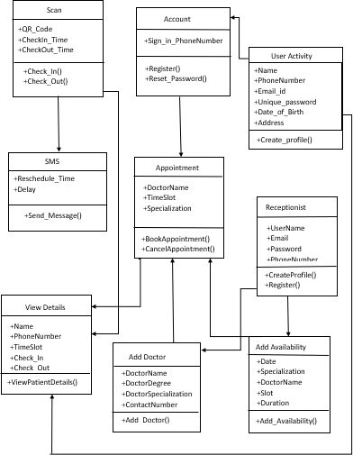

* 1. **Use case Diagram and Description**

Store Details

Checking Availability

Receptionist

Book or Cancel Appointment

User

Scan

Reschedule

UiPath Robot

* 1. **Sequence Diagram**

**User**

**Dashboard**

**Database**

**Receptionist**

**UiPath Robot**

Login/Sign up Phone

Insert/delete Details

Login/Sign

Login/Sign

up up

Email

Successful

Login/Sign up Successful

Add Doctors

/ Availability

Book Appointment

If Available

Successful

User cancel Appointment

Display QRCode Check In/Out

Booking Successful

Appointment Details Deleted

Successful

Scan QR Code Check In/Out

Successful Add Check In/Out

View Details

Retrieve Details successful

Retrieve Check In/Out Time

Retrieve Successful

Send Rescheduled SMS

* 1. **Activity Diagram**

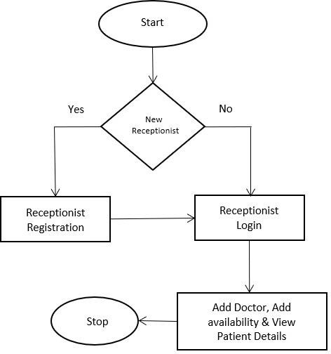

##### Flow Chart for Receptionist

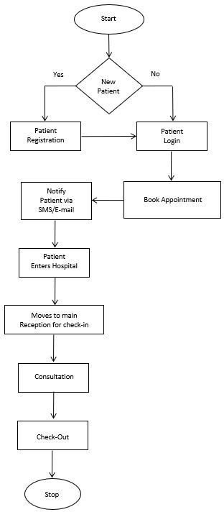

**Flow Chart for Patient**

* 1. **Data flow Diagram**

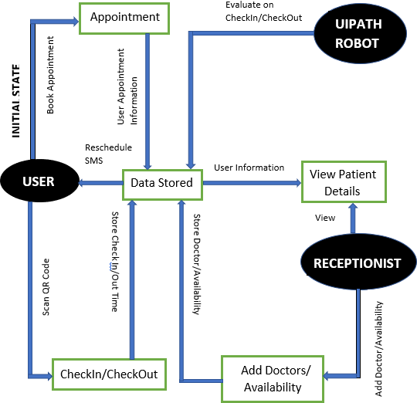

**Chapter – 6 IMPLEMENTATION**

* 1. **Module Implementation**
     1. **Module 1 Functionalities for User**

**IMPLEMENTATION**

NIYUKTHI

* + - 1. GUI for the user is implemented using Django.
      2. At first the user has to register in the Website either by signing in with Phone.
      3. The user is now logged in and can access the main features of the Website.
      4. As soon as the user logs into the Website they can Book Appointment and Manage it.

#### Module 2

**Functionalities for Receptionist**

* + - 1. GUI for Receptionist is implemented using Tkinter.
      2. At first the Receptionist can register using the Desktop Application.
      3. The Receptionist is now logged in and can access the Patient Details.
      4. Receptionist are given additional features like Adding Doctor details, Adding Availability.
      5. They can search for particular patients using names.
      6. Receptionist can view check In/Out details along with the time slot and other basic details of the patient.

#### User Interface for Patient during their visit to hospital implemented using Robotic Process Automation

* + - * 1. Tkinter script is invoked to display the GUI.
        2. Python script is invoked to scan the QR Code for Check In/Out process.
        3. Check In/Out time is stored in firebase which will be updated in the GUI of Receptionist.
        4. When patient doesn’t arrive on allocated time slot the appointment will be cancelled.
        5. Also, if there is any delay in service time or consultation time appointment will be rescheduled for the upcoming patients.
        6. Reschedule appointment SMS will be sent to patient.

Dept. of CSE, MITE, Moodabidri Page 20

# Chapter – 7 TESTING

## TESTING

Testing is an important phase in the development life cycle of the product. During the testing, the program to be tested was executed with a set of test cases and the output of the program for the test cases was evaluated to determine whether the program is performing as expected. Errors were found and corrected by using the following testing steps and correction was recorded for future references. Thus, a series of testing was performed on the system before it was ready for implementation. An important point is that software testing should be distinguished from the separate discipline of Software Quality Assurance (SQA), which encompasses all business process areas, not just testing.

#### Testing Levels

Testing is part of Verification and Validation. Testing plays a very critical role for quality assurance and for ensuring the reliability of the software.

The objective of testing can be stated in the following ways.

* + - A successful test is one that uncovers as-yet-undiscovered bugs.
    - A better test case has high probability of finding un-noticed bugs.
    - A pessimistic approach of running the software with the intent of finding errors.

Testing can be performed in various levels like unit test, integration test and system test.

#### Unit Testing

Unit testing tests the individual components to ensure that they operate correctly. Each component is tested independently, without other system component. This system was tested with the set of proper test data for each module and the results were checked with the expected output. Unit testing focuses on verification effort on the smallest unit of the software design module.

Initially the User/Receptionist try to login with credentials, if the credential is valid the User/Receptionist successfully logs in. Otherwise, User/receptionist receives the error message. User can successfully book the appointment if available time slot is valid else check for next available time slot.

#### Integration Testing

Integration testing is another aspect of testing that is generally done in order to uncover errors associated with the flow of data across interfaces. The unit-tested modules are grouped together and tested in small segment, which makes it easier to isolate and correct errors. This approach is continued until we have integrated all modules to form the system as a whole.

Patient has to scan the QR Code during the visit to hospital the Check In will be successful only if appointment exist. If the appointment does not exist the User should book the appointment before Check-In process. If the consultation time for the current patient is longer than the expected duration then the upcoming patient will get rescheduled SMS. When the current patient fails to arrive at scheduled time slot then their appointment will be cancelled and receive SMS. If the User cancels the appointment their slot will be free and appointment will be deleted from the database.

#### System Testing

System testing is a level of testing that validates the complete and fully integrated software product. The purpose of a system test is to evaluate the end-to-end system specifications. Usually, the software is only one element of a larger computer-based system. Ultimately, the software is interfaced with other software/hardware systems. System Testing is actually a series of different tests whose sole purpose is to exercise the full computer-based system.

In our proposed system the GUI for User developed using Django which takes only 2.3 seconds to load. The scanning of QR Code require 70 seconds and Tkinter application requires 2.9 seconds to process. The rescheduling process carried out by UiPath Robot takes the accurate level of 95% and 97% precise. The cancellation for the appointment takes 20seconds to delete the user appointment.

#### Acceptance Testing

Acceptance Testing is a method of software testing where a system is tested for acceptability. The major aim of this test is to evaluate the compliance of the system with the business requirements and assess whether it is acceptable for delivery or not. After testing the system at different levels, how the complete system is accepted which meets all the mentioned functional and non-functional requirements.

Our proposed system is User friendly web application which enable the user to Book Appointment within a fraction of second. The QR Code scanning method brings security for user details. The User will be notified for each delay and cancellation of appointment.

#### Test Cases

A test case is a software testing document, which consists of events, action, input, output, expected result and actual result. Technically a test case includes test description, procedure, expected result and remarks. Test cases should be based primarily on the software requirements and developed to verify correct functionality and to establish conditions that reveal potential errors.

Individual PASS/FAIL criteria are written for each test case. All the tests need to get a PASS result for proper working of an application.

##### Results: Table 7.2: Test cases for project

|  |  |  |  |  |
| --- | --- | --- | --- | --- |
| **Test Numbers** | **Test Case** | **Expected Results** | **Actual Output** | **Status** |
| 1 | Check User/Receptionist  Login with valid Data | User should Login into an application | As expected, result. | Pass |
| 2 | Check User/Receptionist Login with invalid  Data | User should not Login into an application and should get error message. | As expected, result. | Pass |
| 3 | Booking Appointment for valid availability | User can book appointment successfully. | As expected, result. | Pass |
| 4 | Booking Appointment for invalid availability | User cannot book appointment. | As expected, result. | Pass |
| 5 | User try to scan QR  Code in the hospital if appointment exist. | Successfully Check in | As expected, result. | Pass |
| 6 | User try to scan QR Code in the hospital if appointment doesn’t  exist. | It should show appointment does not exist. | As expected, result. | Pass |
| 7 | Reschedule appointment when user takes extra duration for  consultation. | All the upcoming User gets rescheduled SMS. | As expected, result. | Pass |
| 8 | When User does not come to allotted slot. | Current user will get cancelled SMS. | As expected, result. | Pass |
| 9 | When User cancel the appointment. | The slot is free and the User appointment deleted  from the database. | As expected, result. | Pass |

**Chapter – 8 RESULTS AND SNAPSHOTS**

**RESULTS AND SNAPSHOTS**

* At first the Receptionist can register using the Desktop Application

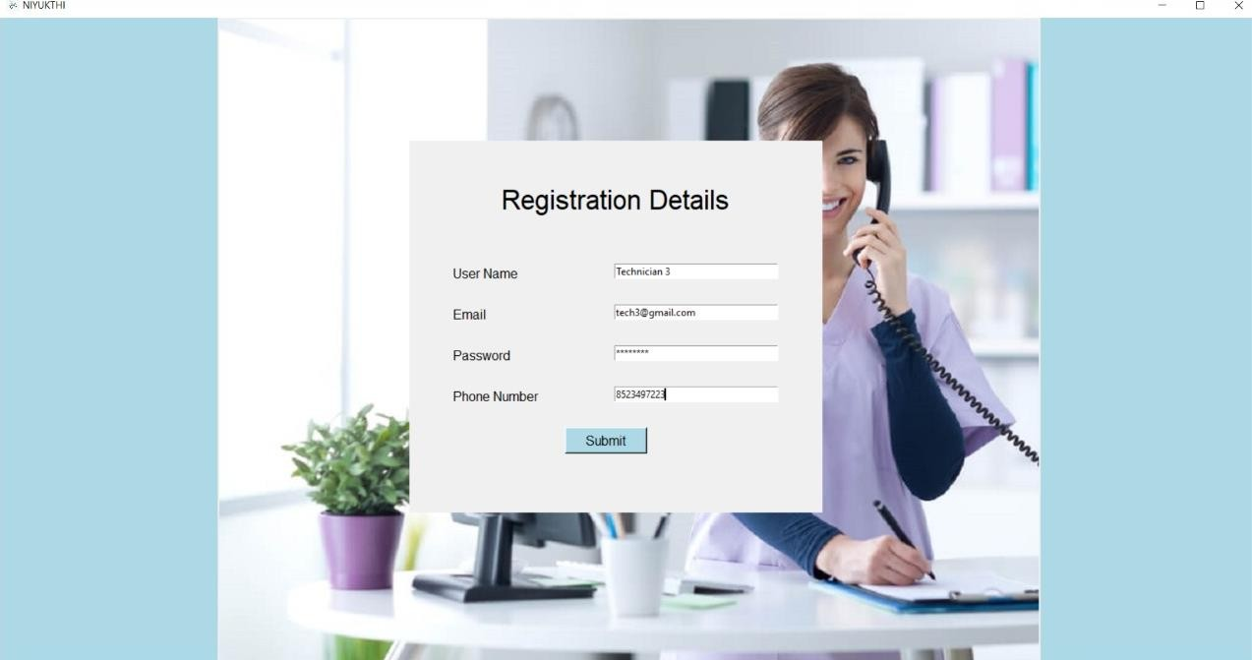

##### Figure 8.1: Sign up page

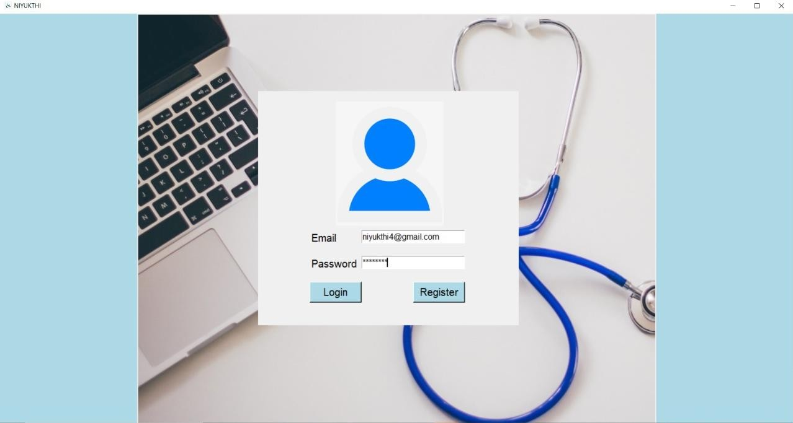

##### Figure 8.2: Login in page

* The Receptionist is now logged in and can access the Patient Details.

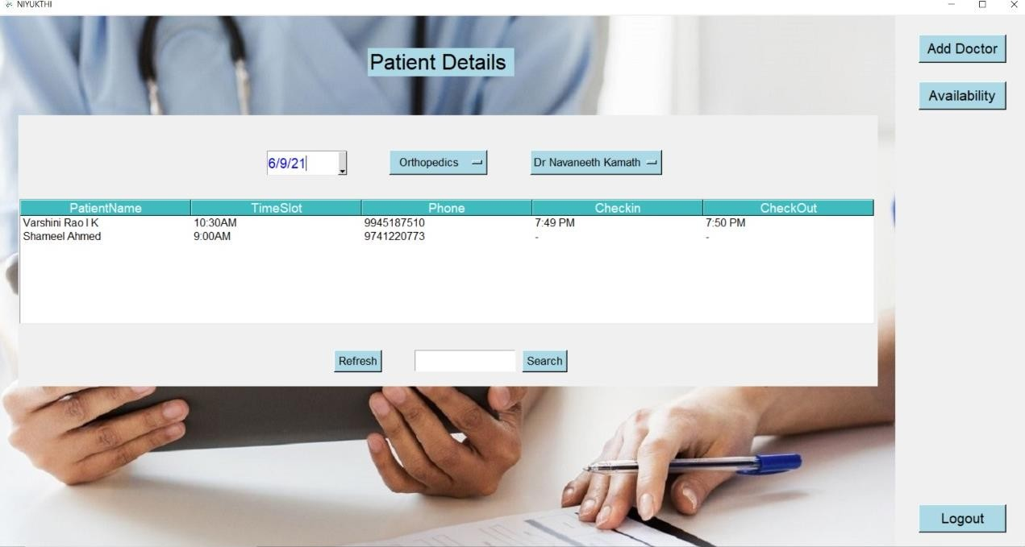

##### Figure 8.3: Patient Details

* 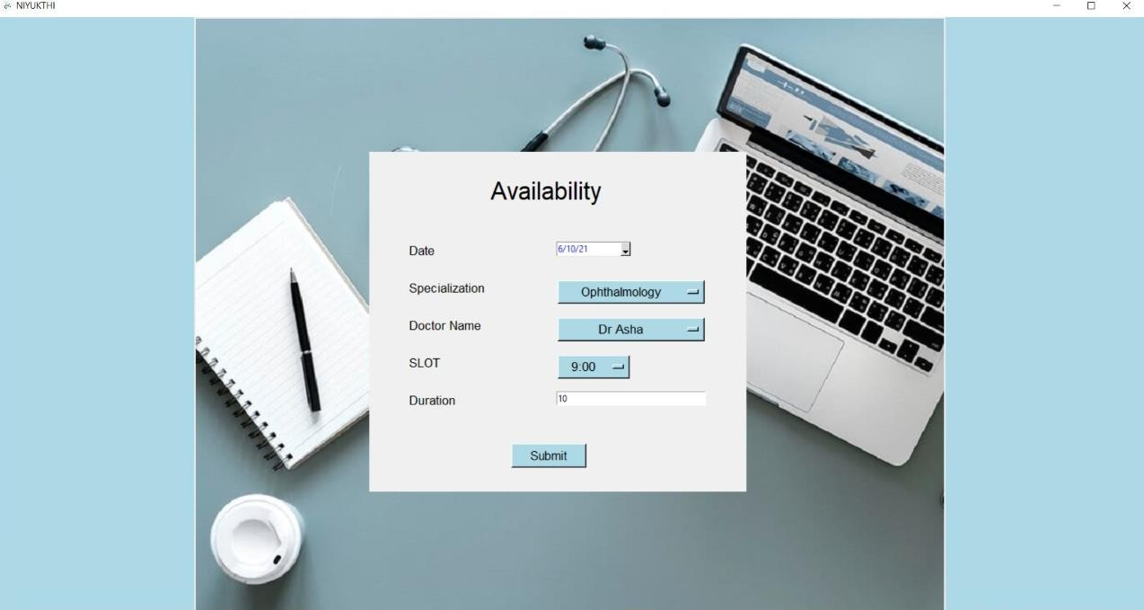Receptionist are given additional features like Adding Doctor details, Adding Availability.

##### Figure 8.4: Availability page

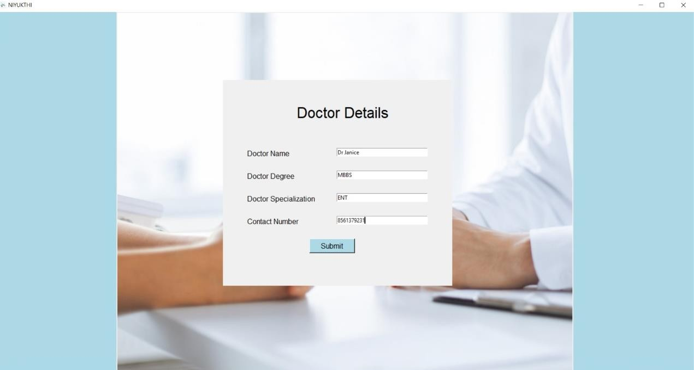

##### Figure 8.5: Add Doctor page

* At first the user has to register in the Website either by signing in with Phone.

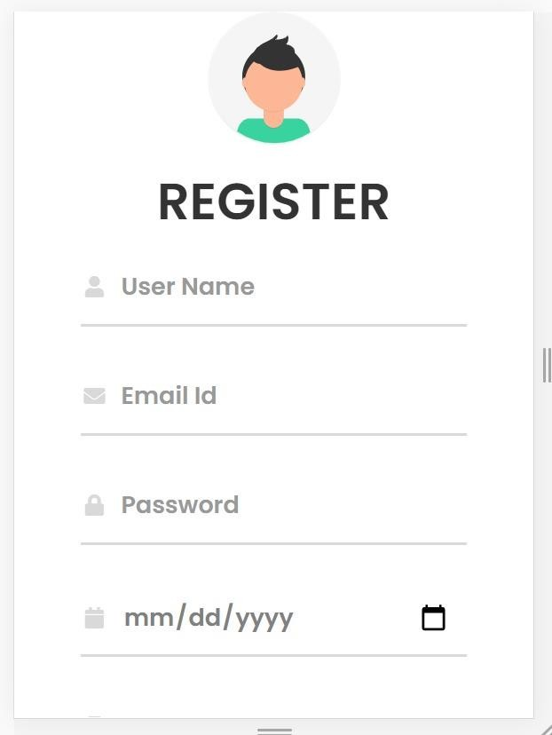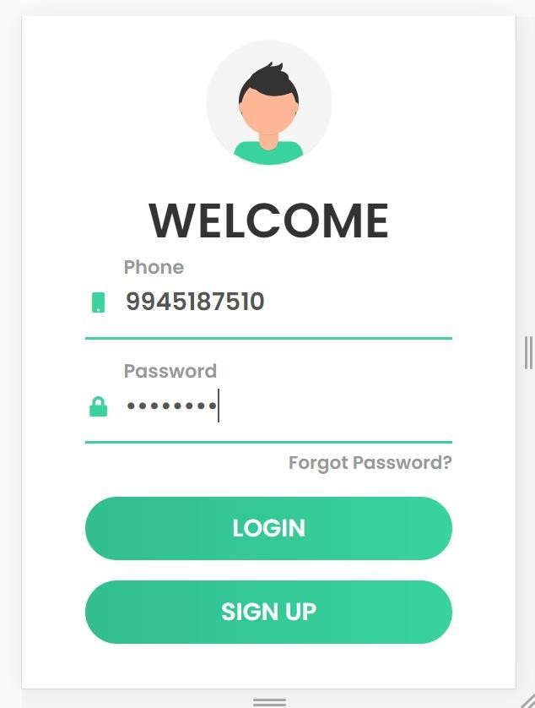

##### Figure 8.6: Register page Figure 8.7: Login page

* Displaying QR Code of User.

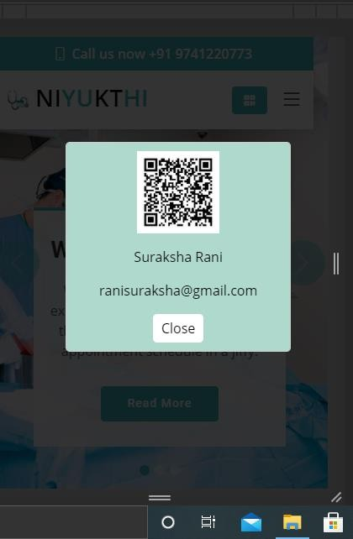

##### Figure 8.8: QR Code

* The User is now logged in and can access the main features of the Website.

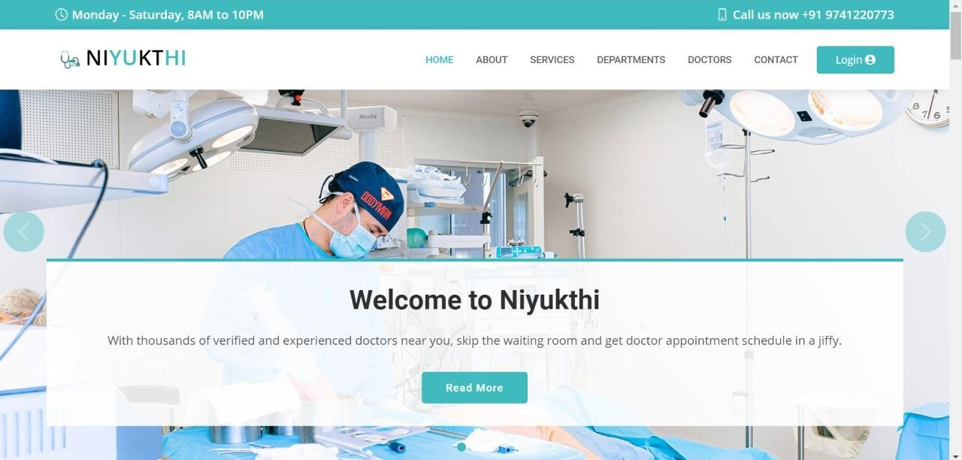

##### Figure 8.9: Home page

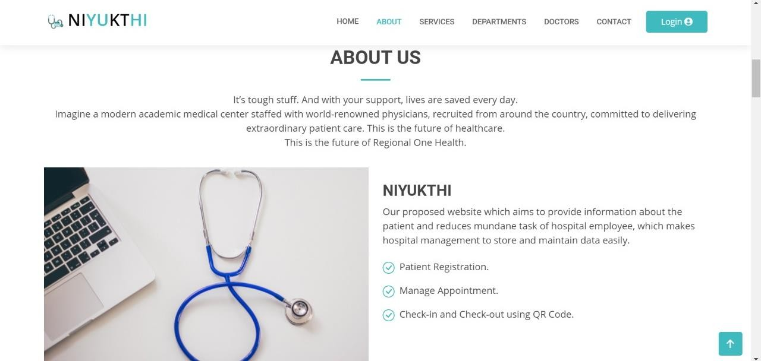

##### Figure 8.10: About Us page

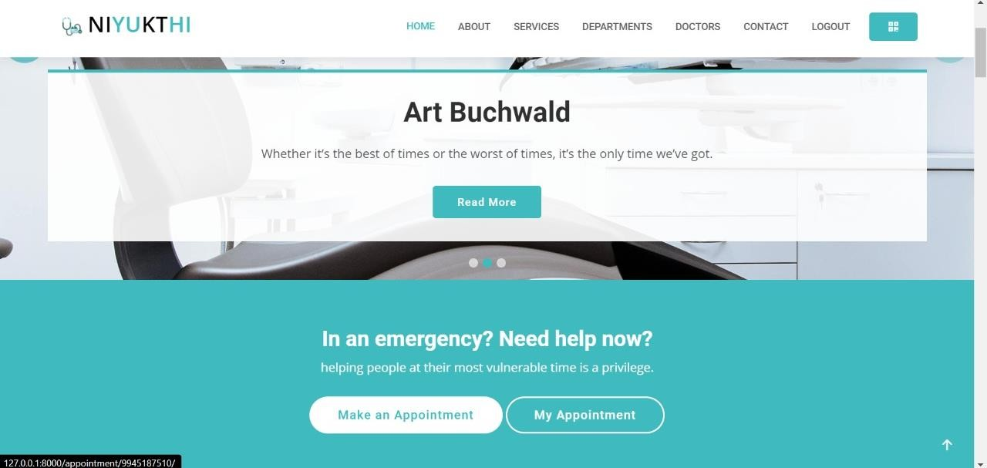

##### Figure 8.11: Make Appointment and Cancel Appointment page

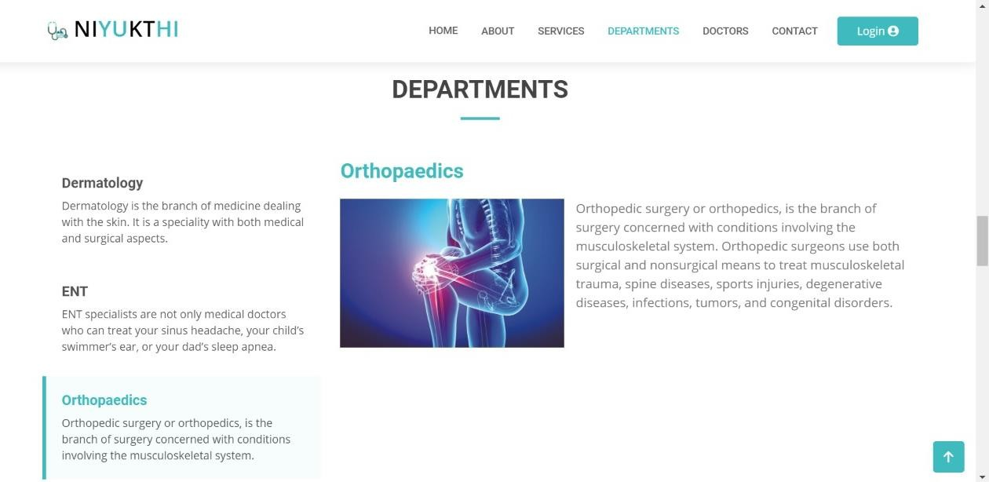

##### Figure 8.12: Department page

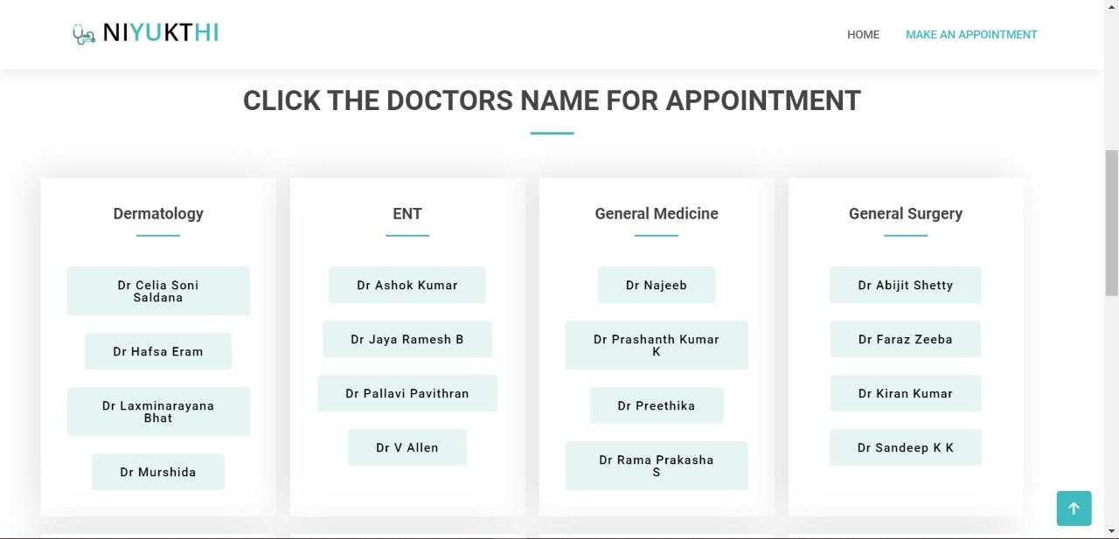

##### Figure 8.13: Doctors Available page

* As soon as the user logs into the Website they can Book Appointment and Manage it.

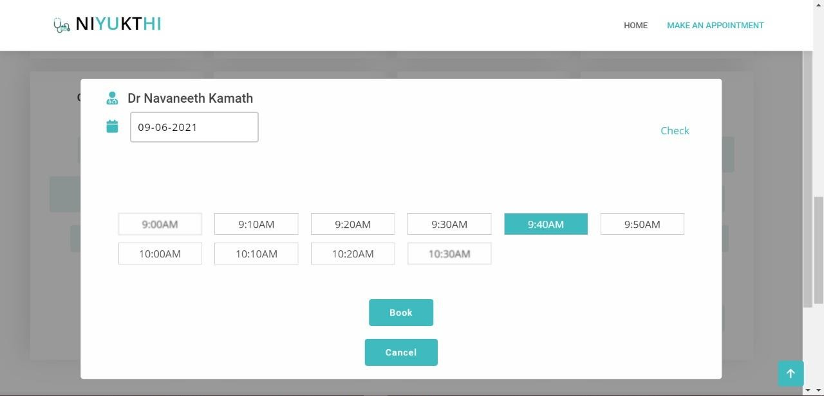

##### Figure 8.14: Booking Appointment page

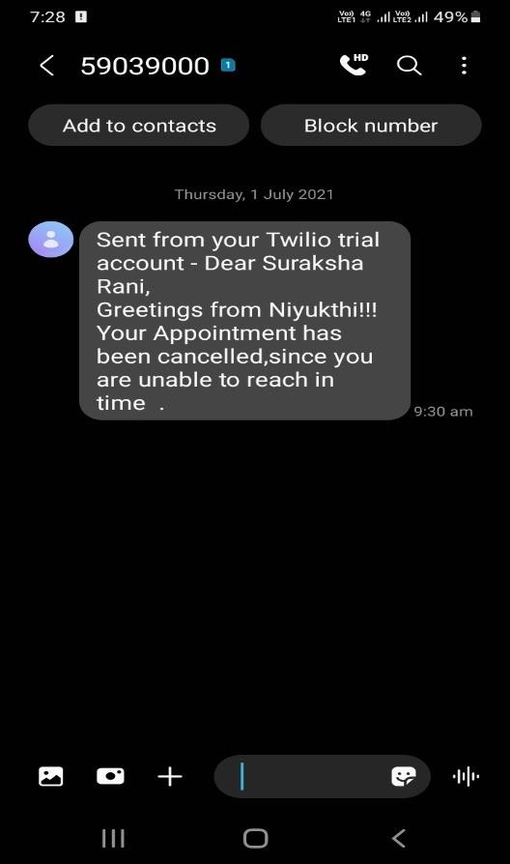

##### Figure 8.15: Appointment cancelled SMS

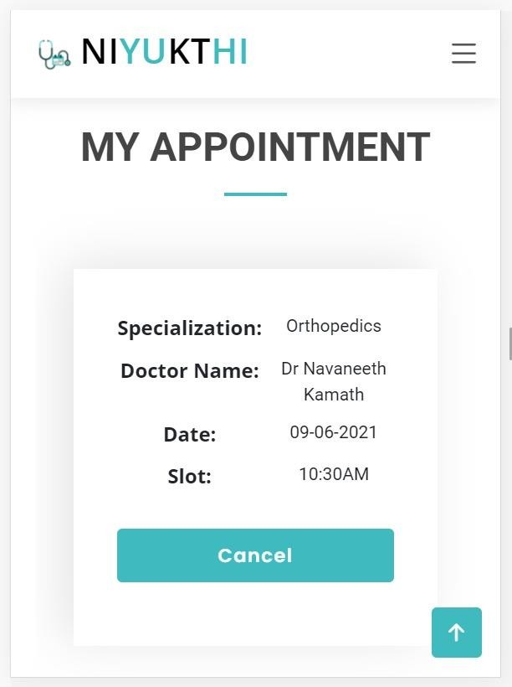 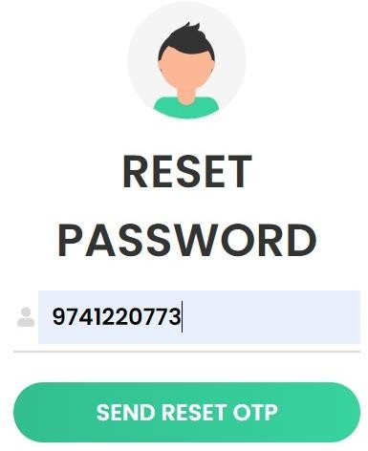

##### Figure 8.16: My Appointment page Figure 8.17: Reset Password page

**Chapter – 9**

**CONCLUSION AND FUTURE WORK**

**CONCLUSION**

Robotic Process Automation (RPA) emerges as software-based solution to automate rules-based business processes that involve routine tasks, structured data and deterministic outcomes. Using RPA, healthcare can automate the check-in process for patients by using service terminals integrated into the facility’s database. Dashboard will take simple data receiving and entry tasks that it could repeat over and over for each patient. Using this website patient can register themself, book appointment and cancel appointment. Whenever the patient checks-in the data will be retrieved at faster rate and accuracy with the help of QR Code. For each cancellation of appointments, upcoming patients will be notified regarding the rescheduled timing through SMS. Rescheduling of appointments is based on Check-in and Check-out timings. The Receptionist will have less work by sitting in front of computers that do relatively routine and formulaic things again and again. They can automate the check-in process for patients by using service terminals integrated into the facility’s database.

## FUTURE WORK

1. The proposed web application is tested in different hospitals and small-scale clinics to obtain a satisfactory result.
2. In future work, we are trying to improve the rescheduling process for various multiple cases.
3. If the current patient fails to arrive then their appointment will be scheduled to the last available slot and notification will be sent to upcoming patient about the rescheduling.
4. The advanced online payment method can be enabled.

# REFERENCES

## REFERENCES

NIYUKTHI

1. Fatma Poni Mardiah, Mursyid Hasan Basri, “The Analysis of Appointment System to Reduce Outpatient Waiting Time at Indonesia’s Public Hospital”, Human Resource Management Research, 3(1) (2013), 27-33
2. Xiuju Zhan, Xiufeng Liu, “Design and Implementation of Clinic Appointment Registration System”, Engineering, (5) (2013), pp.527-529
3. Wenjun Cao et.al, “A web-based appointment system to reduce waiting for outpatients: A retrospective study”, BMC Health Services Research, vol 11, 2011.
4. Cayirli, Tugba, Emre Veral,” Outpatient Scheduling in Healthcare”, Production and Operation Management, vol 12(4)
5. Lucille Keir, Barbara A. Wise, Connie Krebs, Medical Assisting: Essentials of Administrative and Clinical Competencies, Cenage Learning pp.131-1336.
6. Danielle Hayday,”Online Appointment Scheduling”, 2014
7. Xiuju Zhan, Xiufeng Liu, “Design and Implementation of Clinic Appointment Registration

Dept. of CSE, MITE, Moodabidri Page 34